SAP Ariba Supplier Manual

Content

1. Technical requirements 3
2. Supplier registration process 3
2.1. Registration after receiving an invitation to participate in the welcoming event of AIFC 3
2.1.1. How to register 3
2.1.2. Company information 4
2.1.3. User account information 5
2.1.4. Tell us more about your business 6
2.1.5. Supplier profile questionnaire (SPQ) completion 8
2.2. Self-registration with the help of the self-registration link 11
2.2.1. Company information 12
2.2.2. User account information 13
2.2.3. Tell us more about your business 13
2.2.4. Account activation 15
2.2.5. Supplier profile questionnaire (SPQ) completion 17
3. Participation in sourcing events 18
3.1. Participation in “RFI” event 19
3.2. Participation in “RFP” event 20
3.2.1. Alternative response 22
4. User account management 23
4.1. Solutions navigator 24
4.2. Company Settings 24
4.2.1. Changing supplier profile questionnaire (SPQ) 25
4.3. Help Center 25
4.4. User account navigator 26
4.4.1. Changing your user account information and password 26
4.4.2. About Business Roles 26
4.4.3. Linking user accounts 26
4.4.4. Contacting your account administrator 27

Technical requirements
SAP Ariba recommends to use the following versions of internet-browsers:
- Apple Safari 9+ (64 bit);
- Microsoft Internet Explorer 11 (32 bit);
- Microsoft Edge 25;
- Google Chrome 54 - 56 (64 bit);
- Mozilla Firefox 49 - 51 (64 bit).
To identify the browser version you use, please turn to the documentation that is provided by the browser developer.
To prevent errors of the browser it is recommended to delete temporary internet files, cookies, cache and browser history before you start working with SAP Ariba.

Supplier registration process
The suppliers are required to register in Ariba Network to access procurement procedures of Astana International Financial Centre (AIFC).
Supplier registration process can be done in two ways:
- Registration after receiving the invitation to participate in the welcoming event of AIFC.
- Self-registration with the help of the self-registration link.

Registration after receiving an invitation to participate in the welcoming event of AIFC

How to register
- After receiving a notification that you have been registered as a user on Ariba Spend Management site and an invitation to participate in a welcoming event, please use “Click here” to access the event.
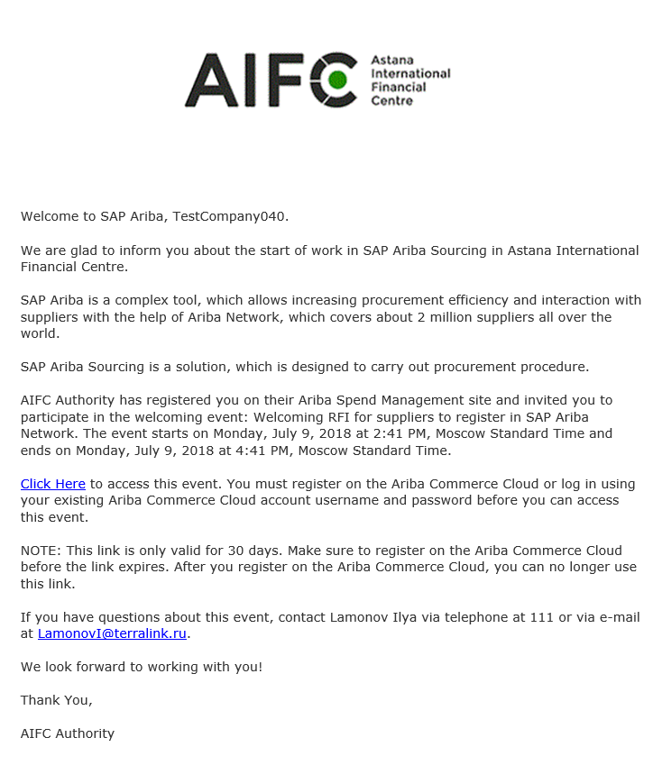
- Click “Sign in” to register and create a user account.
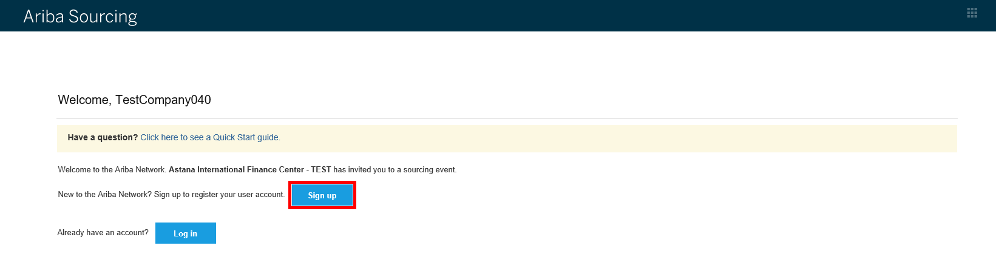

Company information
To create an SAP Ariba supplier account it is required to provide the following company information:
- Company Name;
- Country;
- Postal Code;
- Province/State/Region;
- City;
- Address.
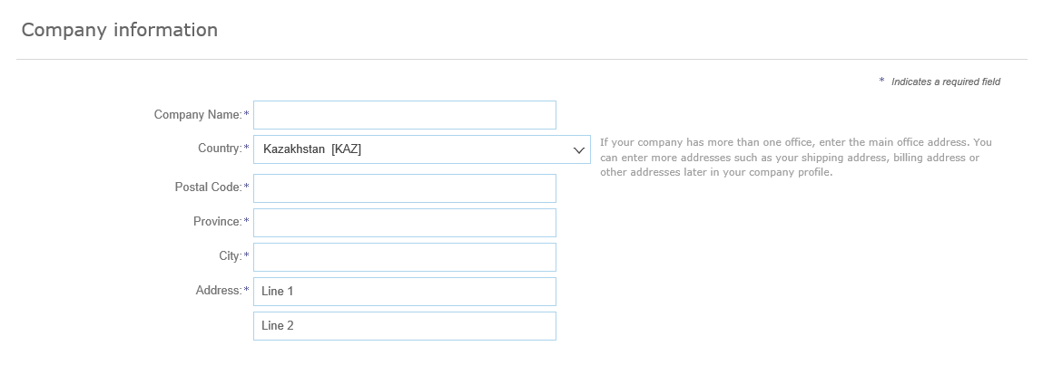

User account information
The user who registers the organization automatically becomes a profile administrator. The administrator is responsible for completing / updating the information about the company.
It is necessary to complete the following user account information:
- Name;
- Email;
- Username;
- Password;
- Language;
- Email orders to.
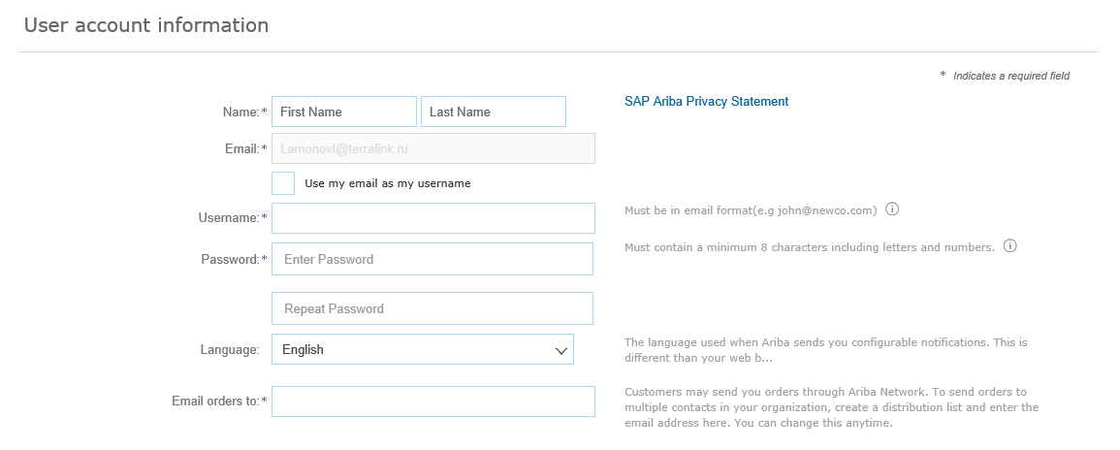

Tell us more about your business
Click “►” to open “Tell us more about your business” section. Here you can complete the following information:
- Product and Service Categories (required);
- Ship-to or Service Locations (required);
- Tax ID (optional);
- DUNS Number (optional).
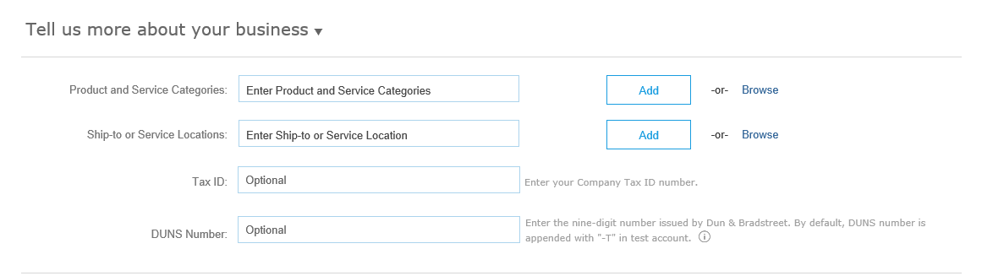
In this section it is necessary to list product and service categories, in this field the United Nations Standard Products and Services Code (UNSPSC) is used. You are also to complete ship-to or service locations.
- Click “Browse to enter product and service categories.
- Click on a category and you see a more detailed list of categories. Select the appropriate product and service categories using “+” button. The supplier can add as many service categories from the list as it is required.
- Check “My Selections” section and click “OK” to add the selected categories.
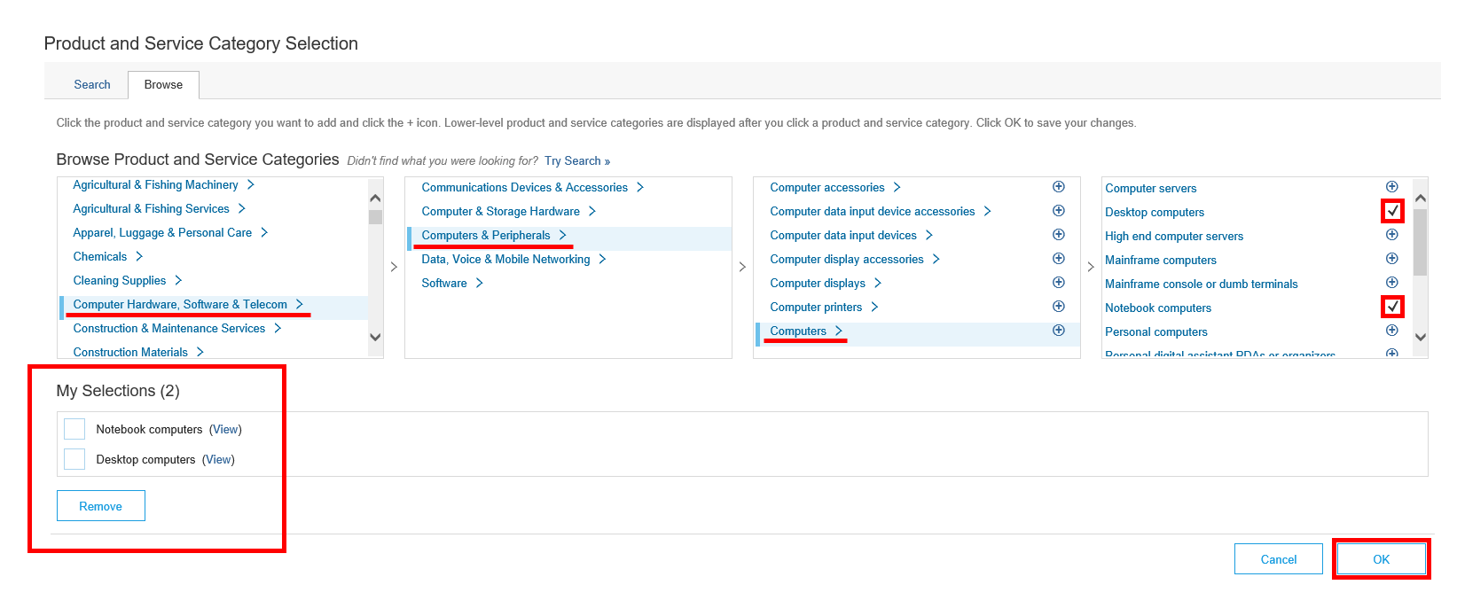
- Click “Browse” to enter ship-to or service locations.
- Click on a region, then select a country or click on a country to select a more precise location using “+” button. Check “My Selections” sections and click “OK”.
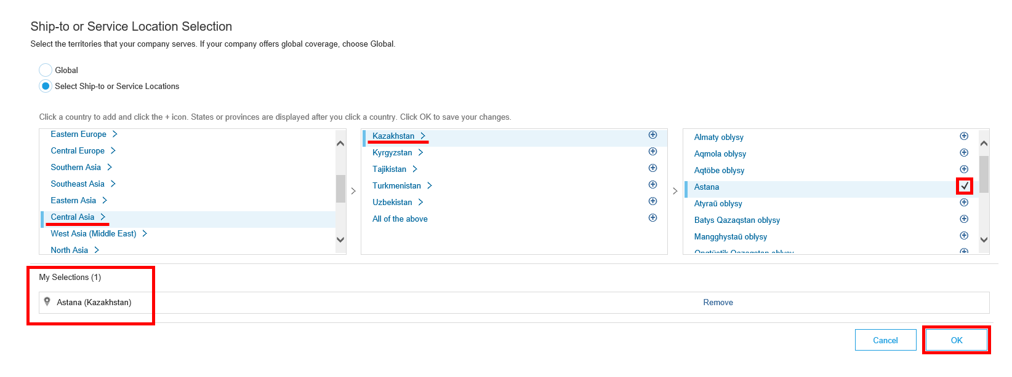
- If your company offers global coverage, choose “Global” and click “OK”.
To finish the registration process read the Terms of Use and the SAP Ariba Privacy Statements, tick “I have read and agree to the Terms of Use” and “I have read and agree to the SAP Ariba Privacy Statement” and click “Create account and continue”.

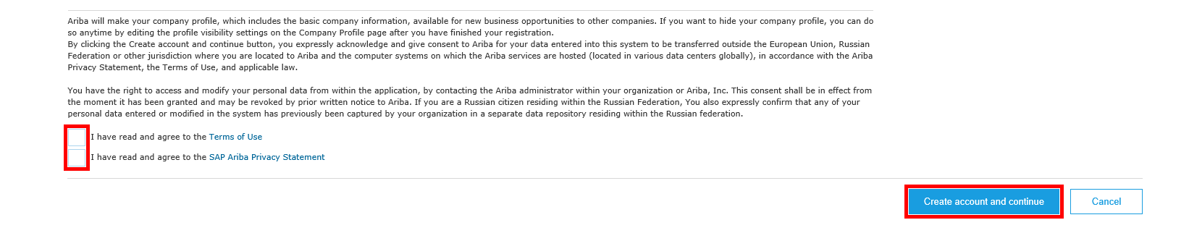
Then you will be taken to the Supplier Login screen. Enter you user name and password and click “Login”.

Supplier profile questionnaire (SPQ) completion
Once you log in to your supplier account you will be taken to the welcoming event. To participate in the event click “Intend to participate”.
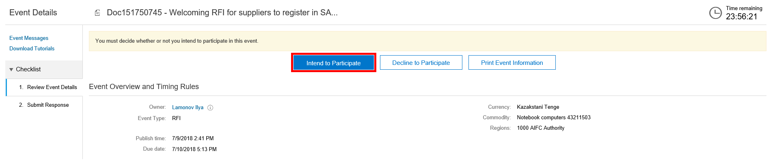
Answer the first question, click “Save” and go to complete a supplier profile questionnaire (SPQ).
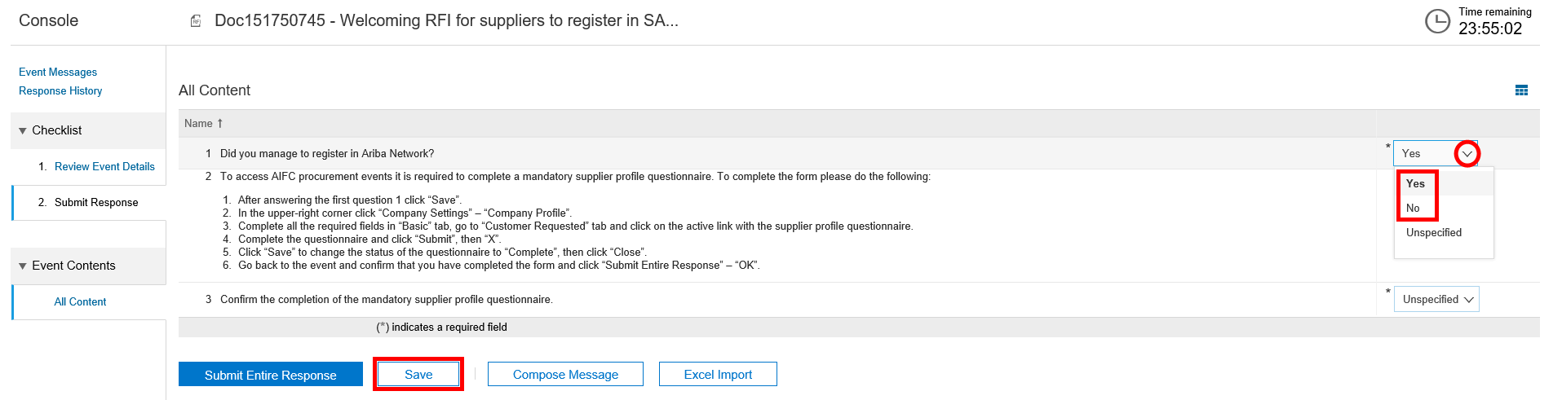
Do the following to complete the supplier profile questionnaire:
- In the upper-right corner click “Company Settings” – “Company Profile”.
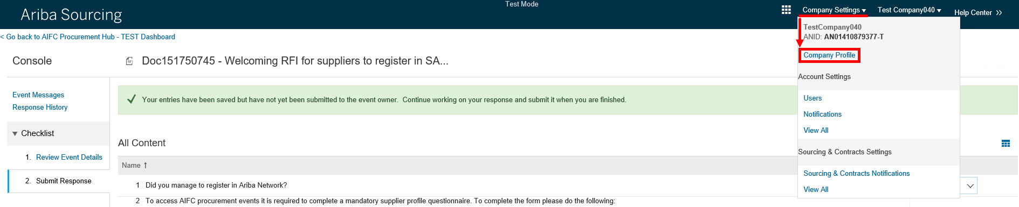
- Complete all the required fields in “Basic” tab if they were not completed before, then go to “Customer Requested” tab and click on the name of the supplier profile questionnaire.
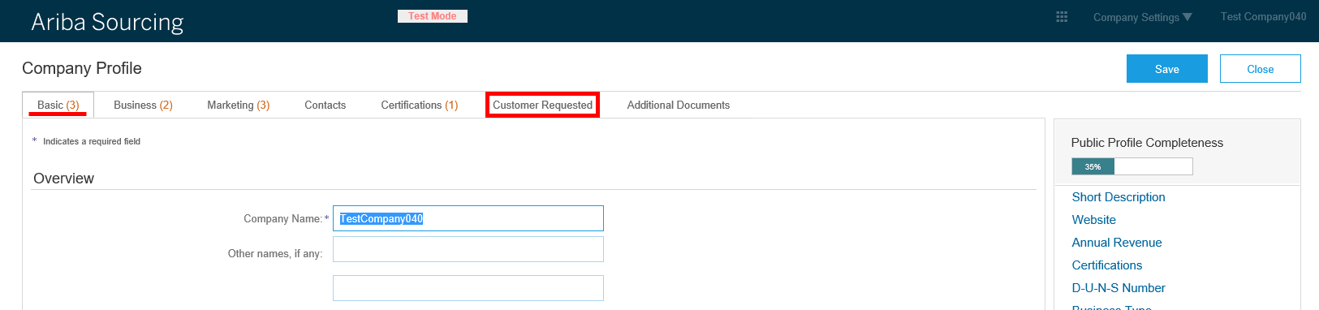
- Complete the questionnaire paying attention to the SPQ requirements, listed below.
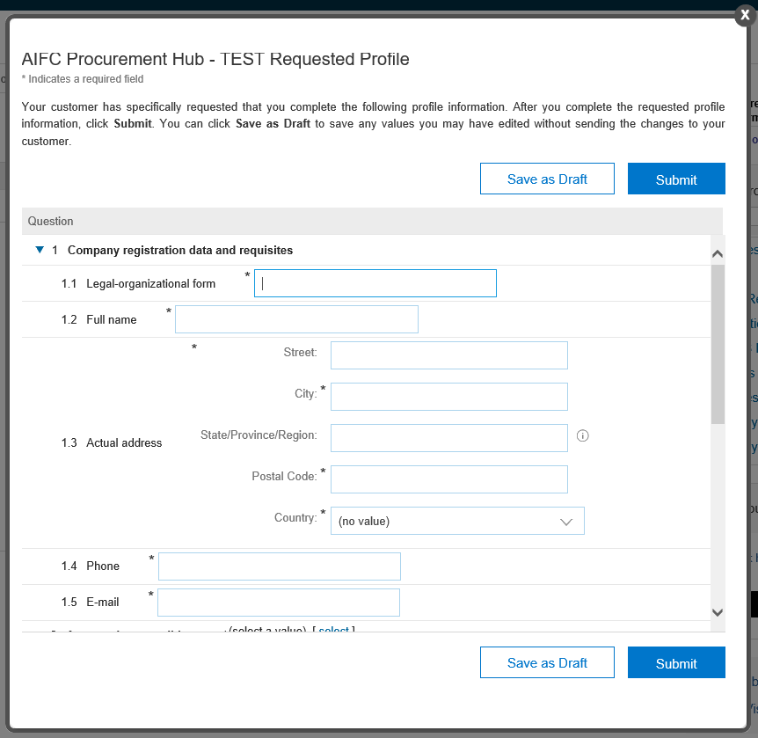
SPQ completion requirements:
- Legal-organizational form – provide the abbreviation of legal-organizational form of your company.
- Full name – the full name of your organization without abbreviations (specify without quotes).
- Actual address – specify the index, country, city, street, building number, office number, where your organization is actually located.
- Approved commodities – select goods and services that you provide.
- Individual Identification Number / Registration certificate of a foreigner as a taxpayer in the Republic of Kazakhstan – specify IIN of your organization consisting of 12 characters.
- Business Identification Number (legal entity registration certificate) – specify BIN of your company consisting of 12 characters.

- Once you have completed the SPQ click “Submit” and “X”.
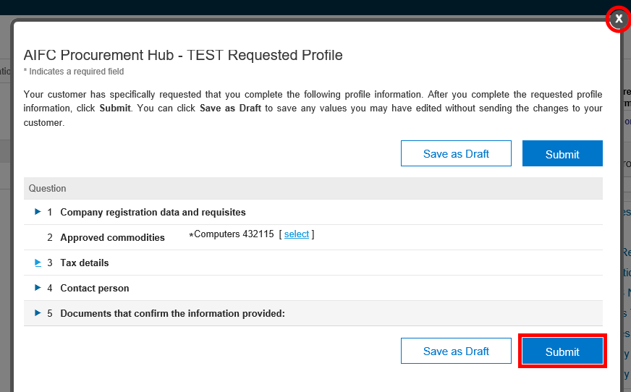
- Click “Save” to change the status of the questionnaire to “Complete”.
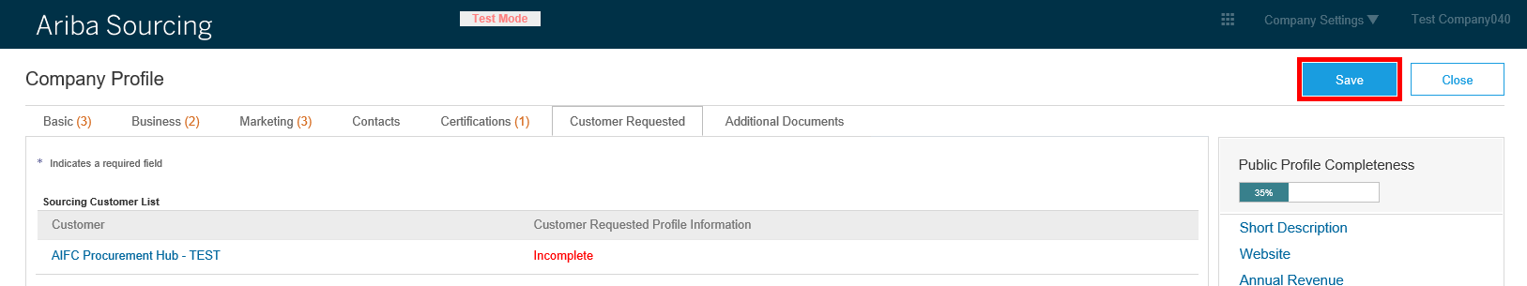
- Make sure the status of the questionnaire has been changed to “Complete”, then click “Close”.

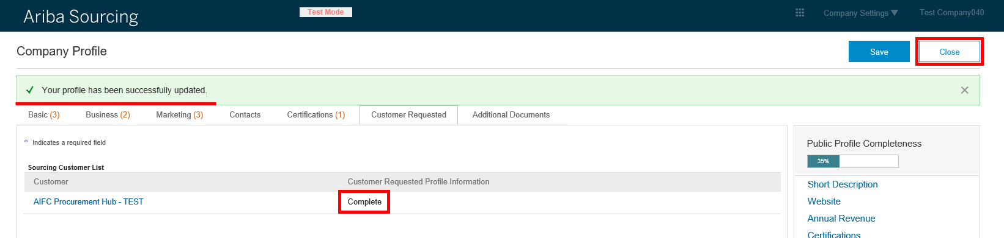
- Go back to the event and confirm that you have completed the form and click “Submit Entire Response” – “OK”.
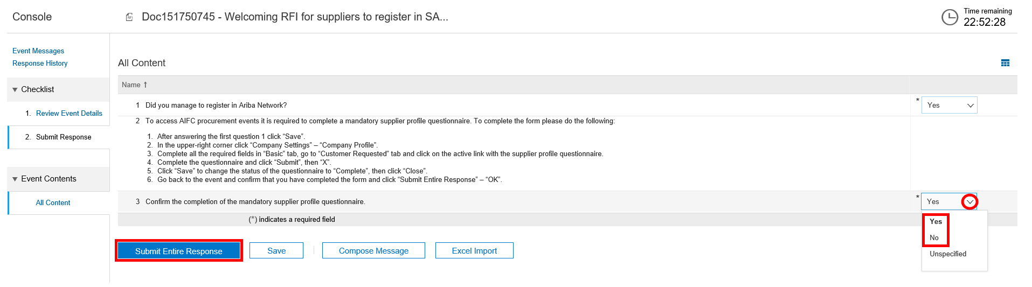

Self-registration with the help of the self-registration link
If the invitation to register in the procurement system of AIFC was not sent to a supplier, it is possible for a supplier to register with the help of a self-registration link.
Go to the self-registration site by copying the link below and pasting it into the address bar of your browser:
http://AIFC.supplier-eu.ariba.com/register
You will need to provide basic company information, user account information, activate your account and complete supplier profile questionnaire to access the procurement procedures of AIFC.
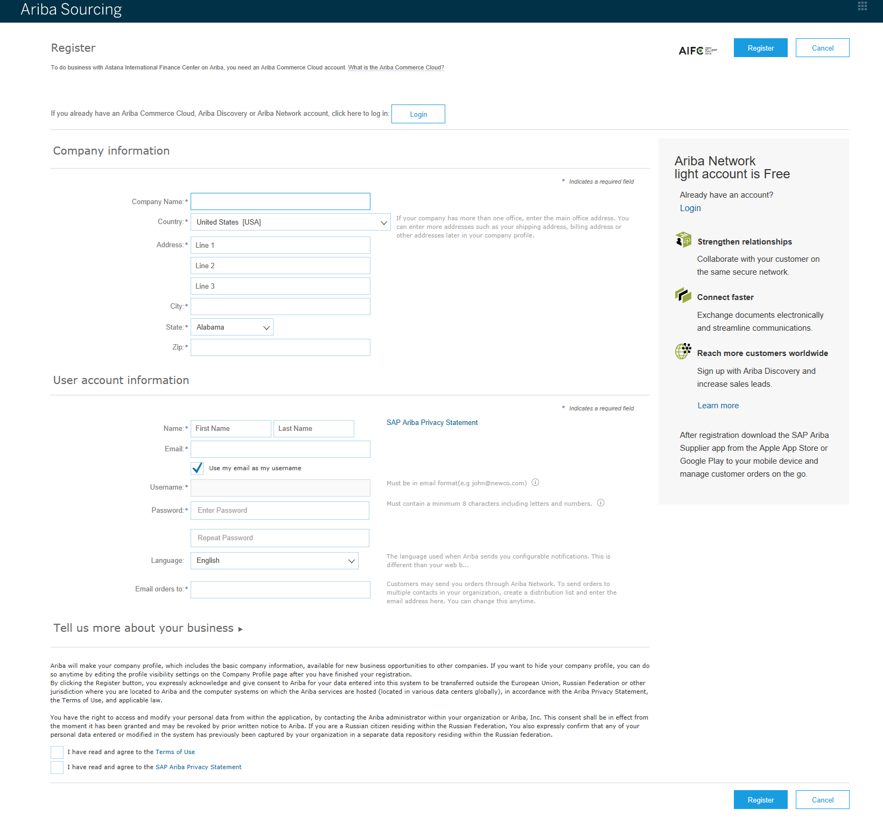

Company information
To create an SAP Ariba supplier account it is required to provide the following company information:
- Company Name;
- Country;
- Postal Code;
- Province/State/Region;
- City;
- Address.
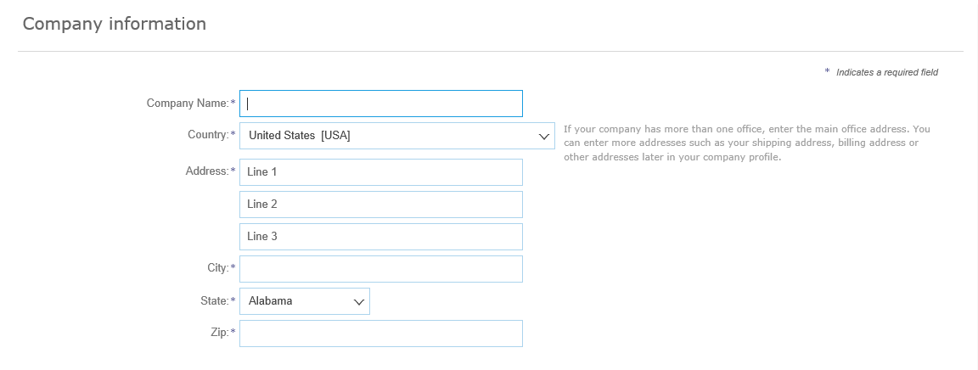

User account information
The user who registers the organization automatically becomes a profile administrator. The administrator is responsible for completing / updating the information about the company.
It is necessary to complete the following user account information:
- Name;
- Email;
- Username;
- Password;
- Language;
- Email orders to.
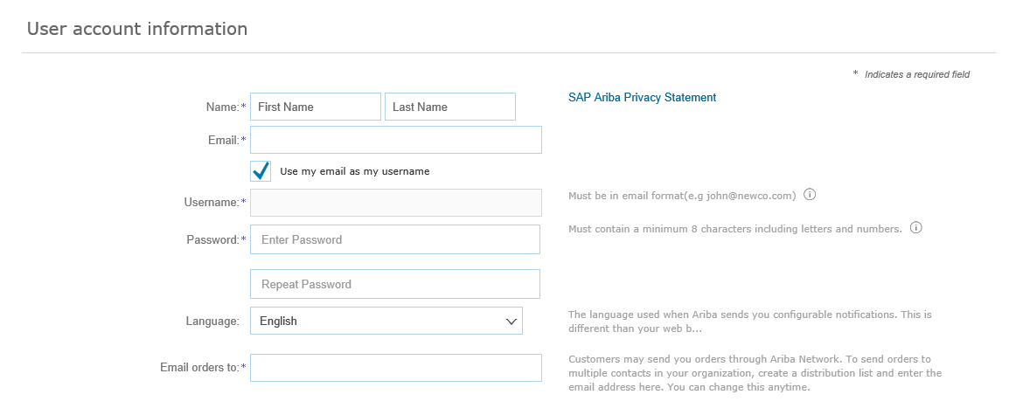

Tell us more about your business
Click “►” to open “Tell us more about your business” section. Here you can complete the following information:
- Product and Service Categories (required);
- Ship-to or Service Locations (required);
- Tax ID (optional);
- DUNS Number (optional).
In this section it is necessary to list product and service categories, in this field the United Nations Standard Products and Services Code (UNSPSC) is used. You are also to complete ship-to or service locations.
- Click “Browse to enter product and service categories.
- Click on a category and you see a more detailed list of categories. Select the appropriate product and service categories using “+” button. The supplier can add as many service categories from the list as it is required.
- Check “My Selections” section and click “OK” to add the selected categories.
- Click “Browse” to enter ship-to or service locations.
- Click on a region, then select a country or click on a country to select a more precise location using “+” button. Check “My Selections” sections and click “OK”.
- If your company offers global coverage, choose Global and click “OK”.
To finish the registration process read the Terms of Use and the SAP Ariba Privacy Statements, tick “I have read and agree to the Terms of Use” and “I have read and agree to the SAP Ariba Privacy Statement” and click “Register”.
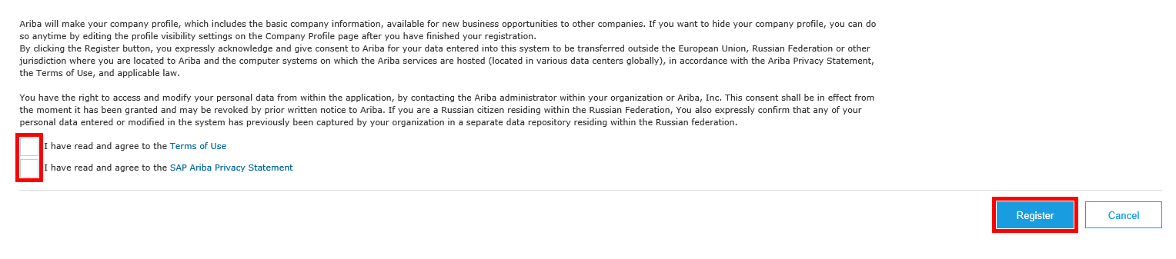

Account activation
Once you have completed and submitted the supplier registration form, an email will be sent to the mentioned address to activate the Ariba account.
To complete the registration process click on the link to confirm your address and complete a supplier profile questionnaire (SPQ) specified by Astana International Finance Center.
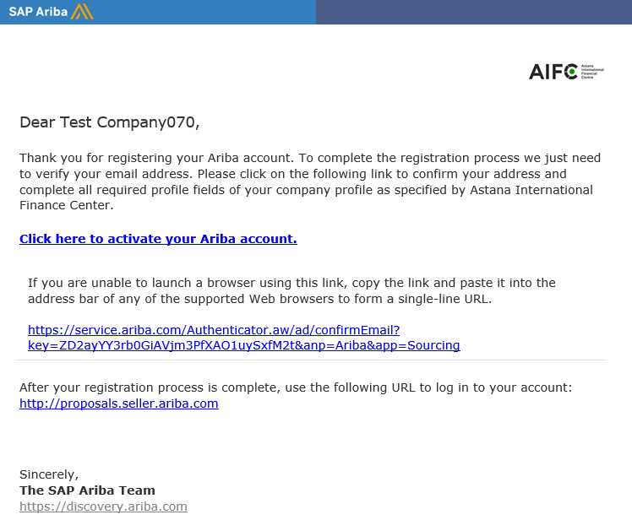
Once you click on the link you will be taken to the supplier profile questionnaire. You must complete and submit the supplier profile information before you can access and participate in AIFC events.
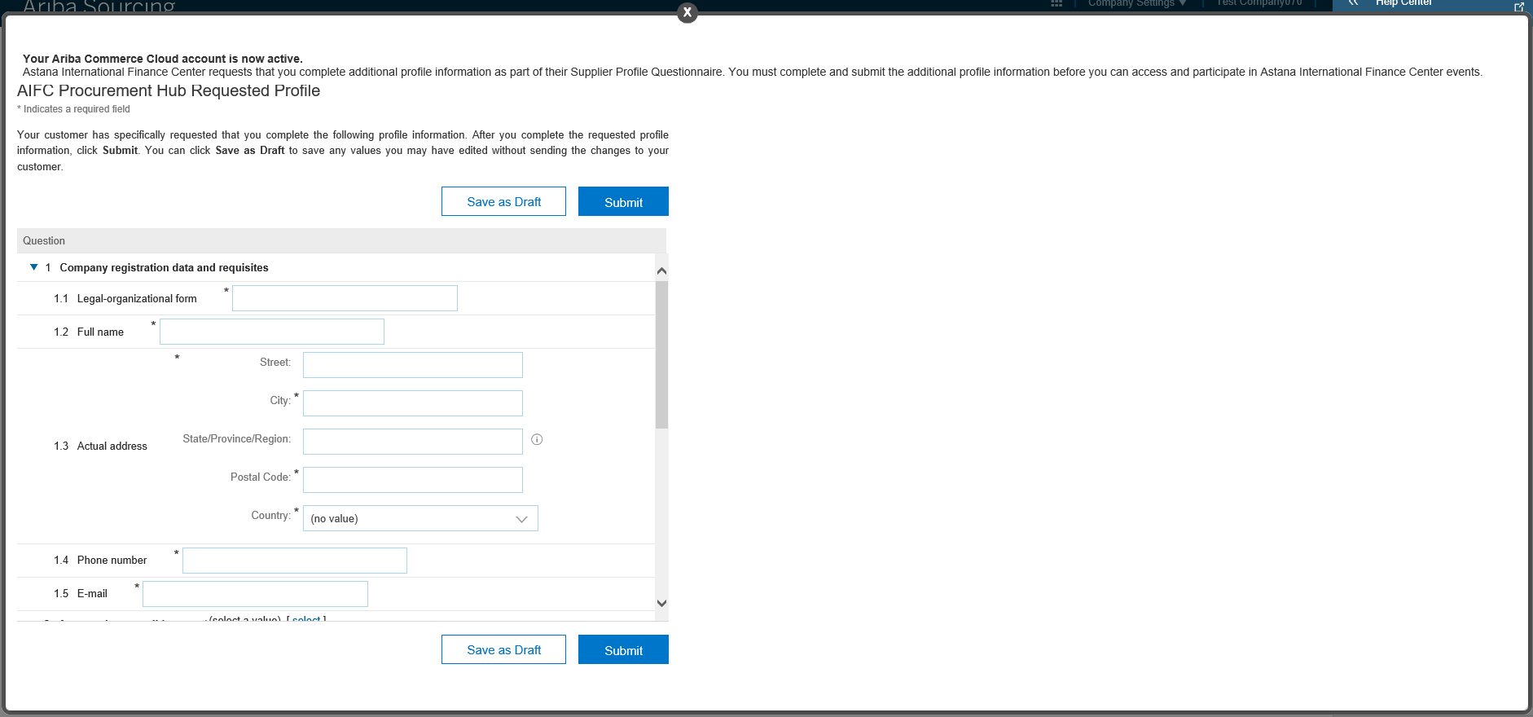

Supplier profile questionnaire (SPQ) completion
If you used the account activation link to go to SAP Ariba, the supplier profile questionnaire will open automatically.
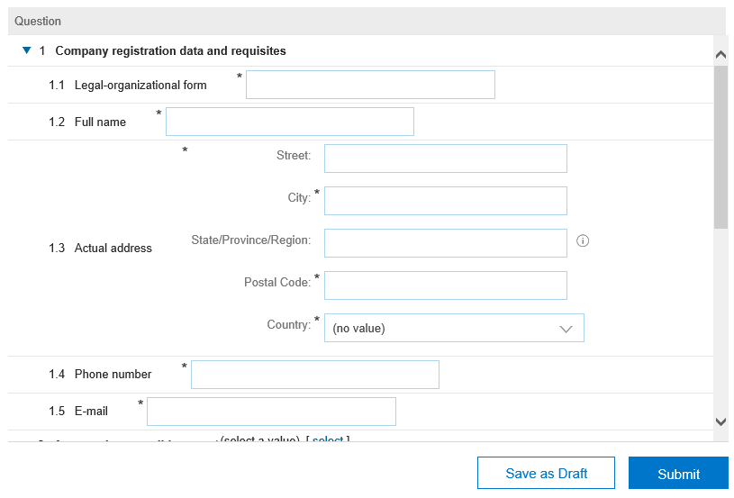

SPQ completion requirements:
- Legal-organizational form – provide the abbreviation of legal-organizational form of your company.
- Full name – the full name of your organization without abbreviations (specify without quotes).
- Actual address – specify the index, country, city, street, building number, office number, where your organization is actually located.
- Approved commodities – select goods and services that you provide.
- Individual Identification Number / Registration certificate of a foreigner as a taxpayer in the Republic of Kazakhstan – specify IIN of your organization consisting of 12 characters.
- Business Identification Number (legal entity registration certificate) – specify BIN of your company consisting of 12 characters.
Once you have completed the SPQ click “Submit”. Then you will be taken to the Supplier Login screen. Enter you user name and password and click “Login” to log into your supplier account.

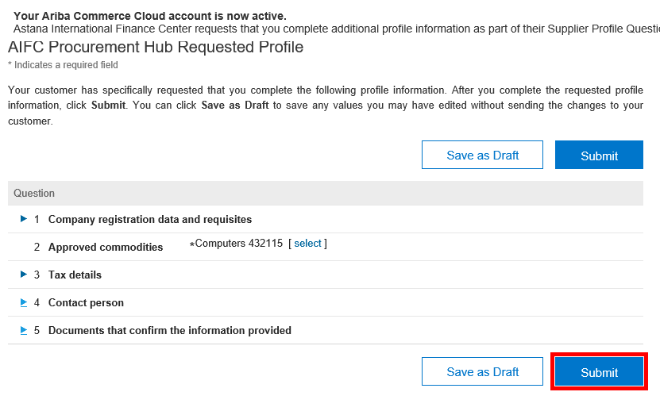
Note! Your requested profile information is submitted to an AIFC representative and it needs to be approved by him. Once your request is approved AIFC will be able to invite you to their sourcing events.

Participation in sourcing events
On the main page of the supplier interface in “Events” section all events are displayed that you are invited to participate in.
There are two types of events:
- Request for information (RFI);
- Request for proposal (RFP).
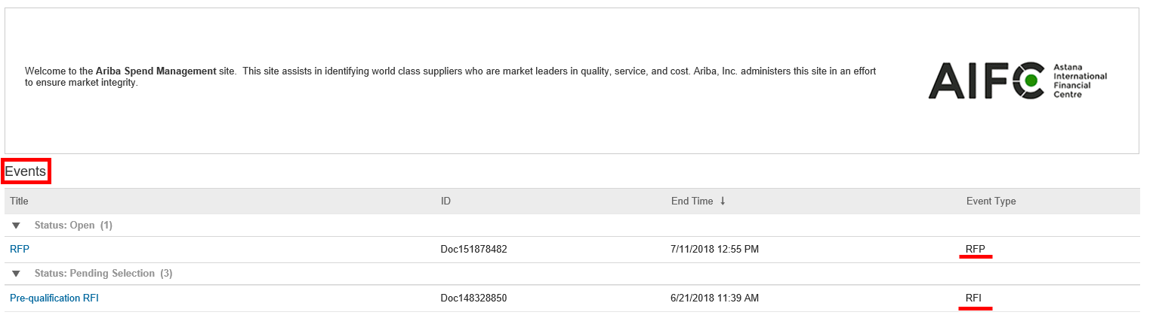
Click on the event name in “Open” status to participate in a sourcing event.
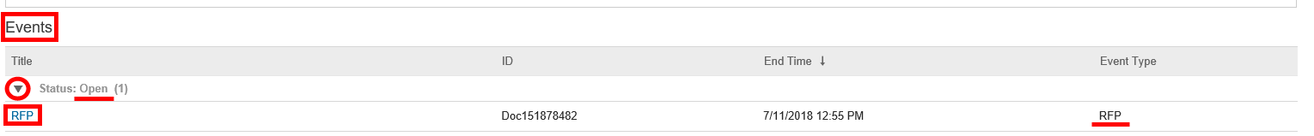

Participation in “RFI” event
There are two types of requests for information (RFI):
- Pre-qualification request for information;
- Request for conceptual proposal.
You need to review and respond to prerequisites to participate in an event. Click “Review Prerequisites” to do it.
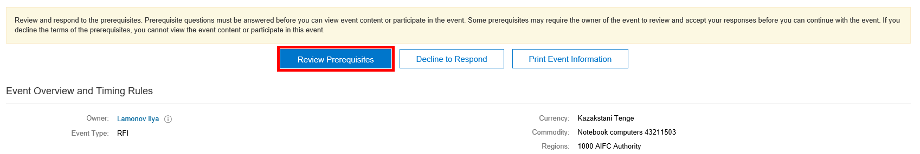
Review Bidder Agreement terms and conditions, accept the terms of the agreement and click “OK” – “OK”.
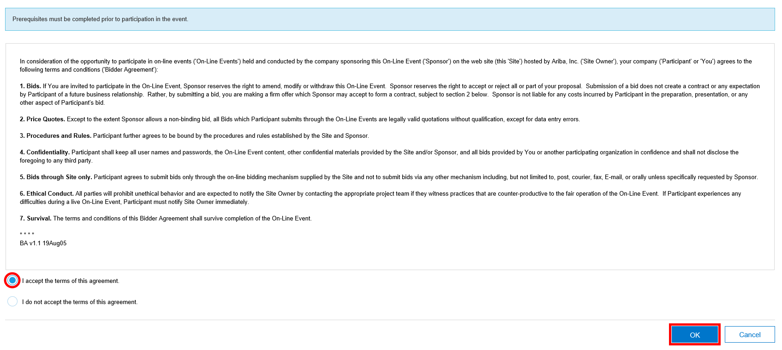
In “Submit Response” section complete the necessary information and click “Submit Entire Response” – “OK”.
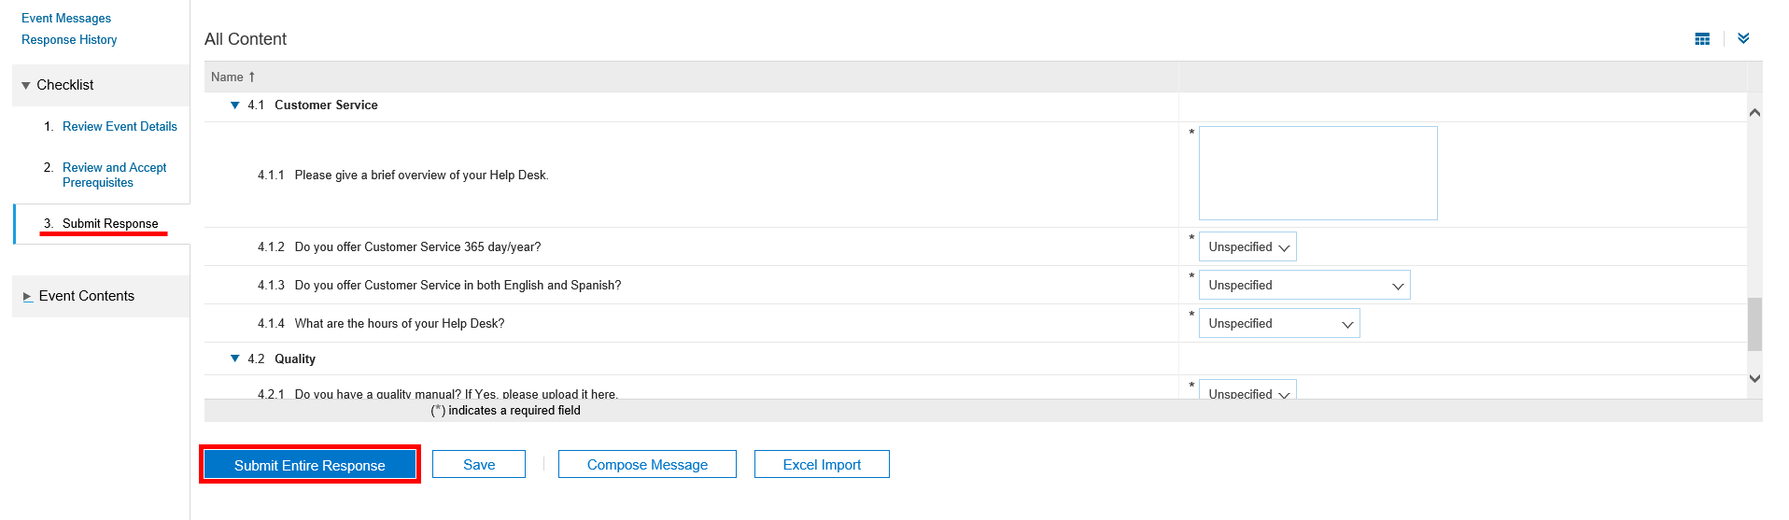
When the sourcing event is finished and supplier responses are analyzed you will receive an email notification with the result of the sourcing event. In case of a positive result you will be invited to participate in the next stage of the procurement procedure.

Participation in “RFP” event
There are two types of RFP:
- Request for technical and commercial proposal;
- Request for discount.
You need to review and respond to prerequisites to participate in an event. Click “Review Prerequisites” to do it.
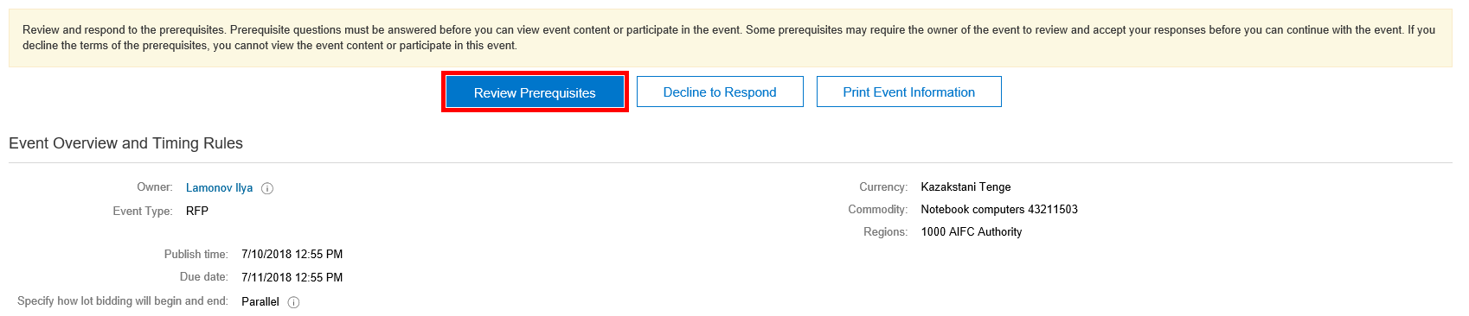
Review Bidder Agreement terms and conditions, accept the terms of the agreement and accept the modified envelope bidding event agreement and click “OK” – “OK”.
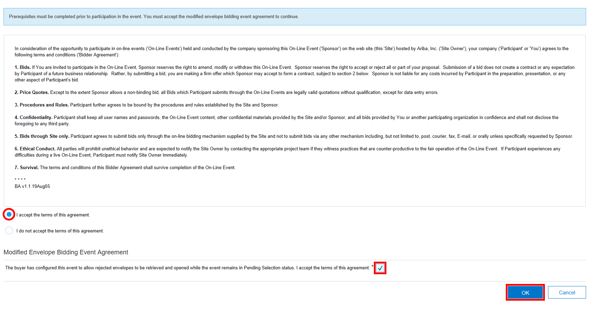
Once you have reviewed and accepted prerequisites you need to select lots.
Select event bidding currency, tick lots which the proposal will be submitted for, if they are not ticked, then click “Submit Selected Lots”.
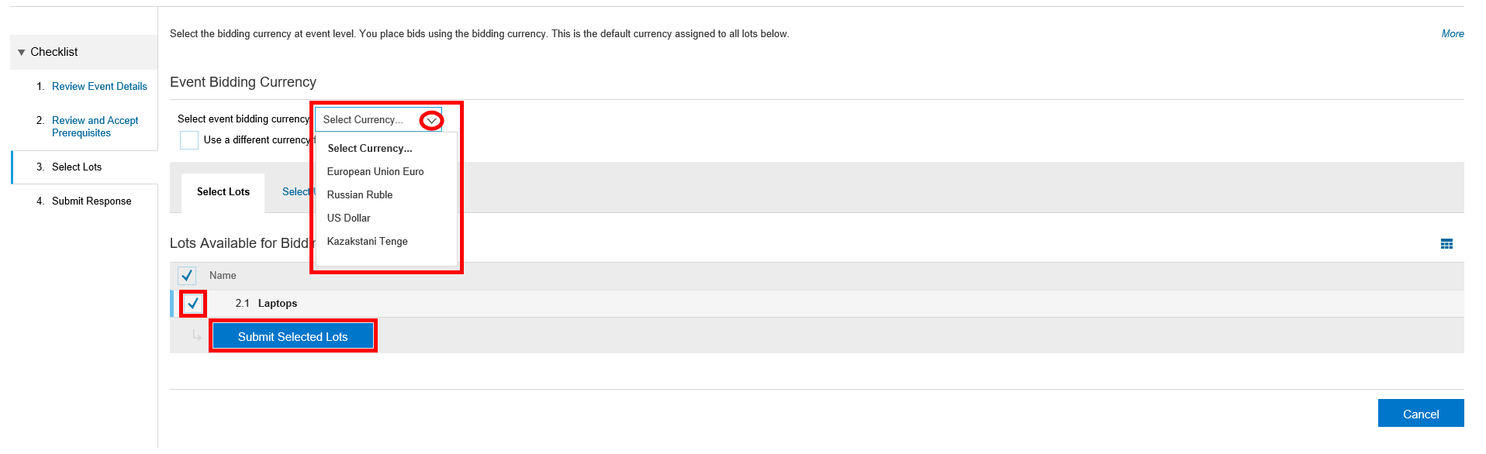
In “Submit Response” section complete the necessary information and click “Submit Entire Response” – “OK”.
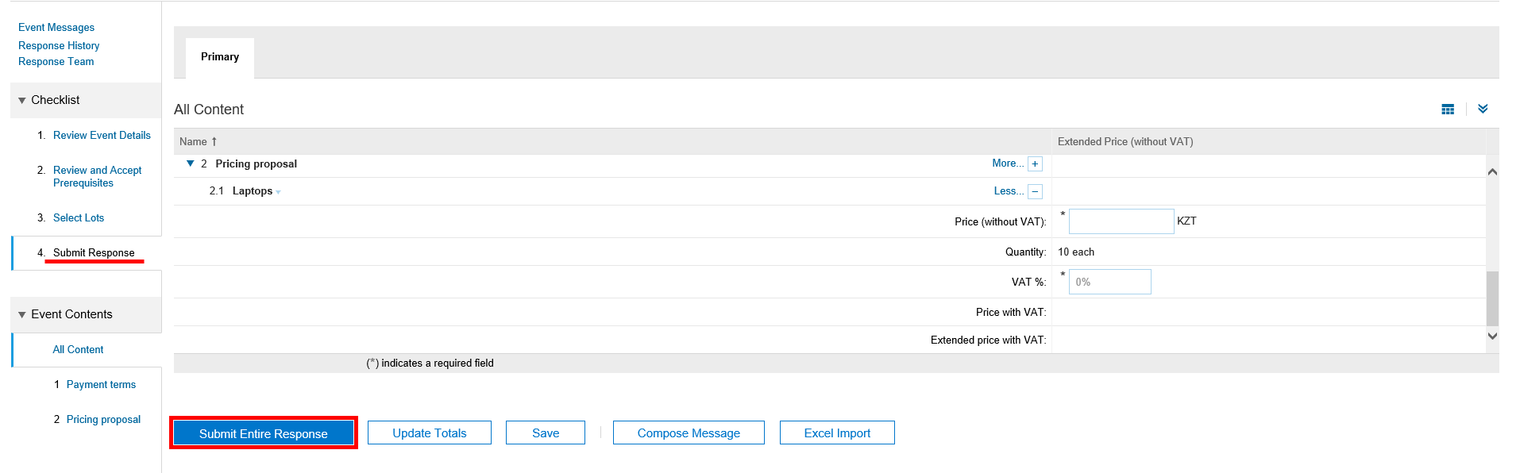
When the sourcing event is finished and supplier responses are analyzed you will receive an email notification of the result of the sourcing event. In case of positive decision about request for technical and commercial proposal you may receive an invitation to participate in a request for discount event. If request for discount is not stipulated, the winner receives an email notification to confirm willingness to fulfill commitments.
Once commitments fulfillment is confirmed the supplier receives an email notification that they have been awarded as a winner of certain lots of the procurement procedure.
If you are not awarded in the procurement procedure, you will receive an email notification that other participant(s) have been awarded as a winner.

Alternative response
A supplier can change their response at any time up until the event closes – the time remaining for an event is displayed at the right hand corner of the screen.
To submit an alternative proposal click “Revise/Alternative response” – “OK”. Then in “Submit Response” section click “Alternative” – “Pricing Alternative” to submit a proposal with an alternative price.
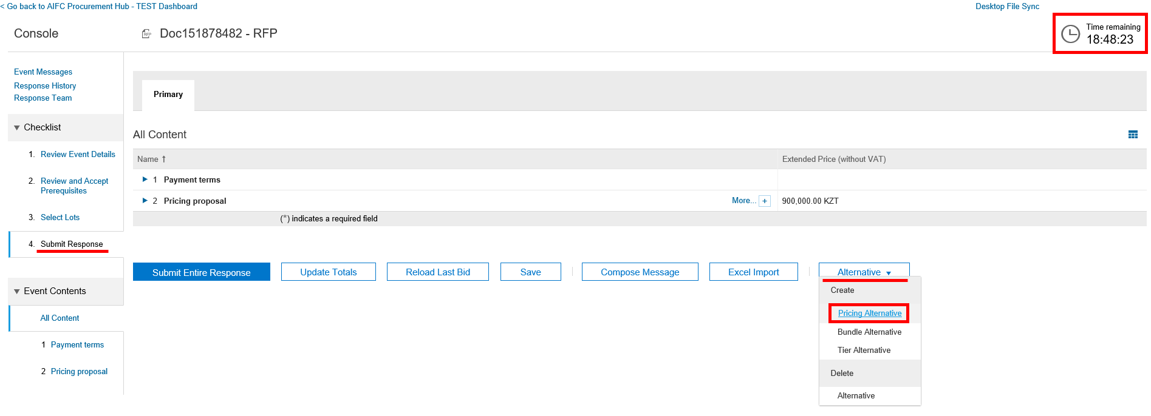
Enter a name for the alternative response, tick the items you want to include and click “OK” to add the items to the alternative response.
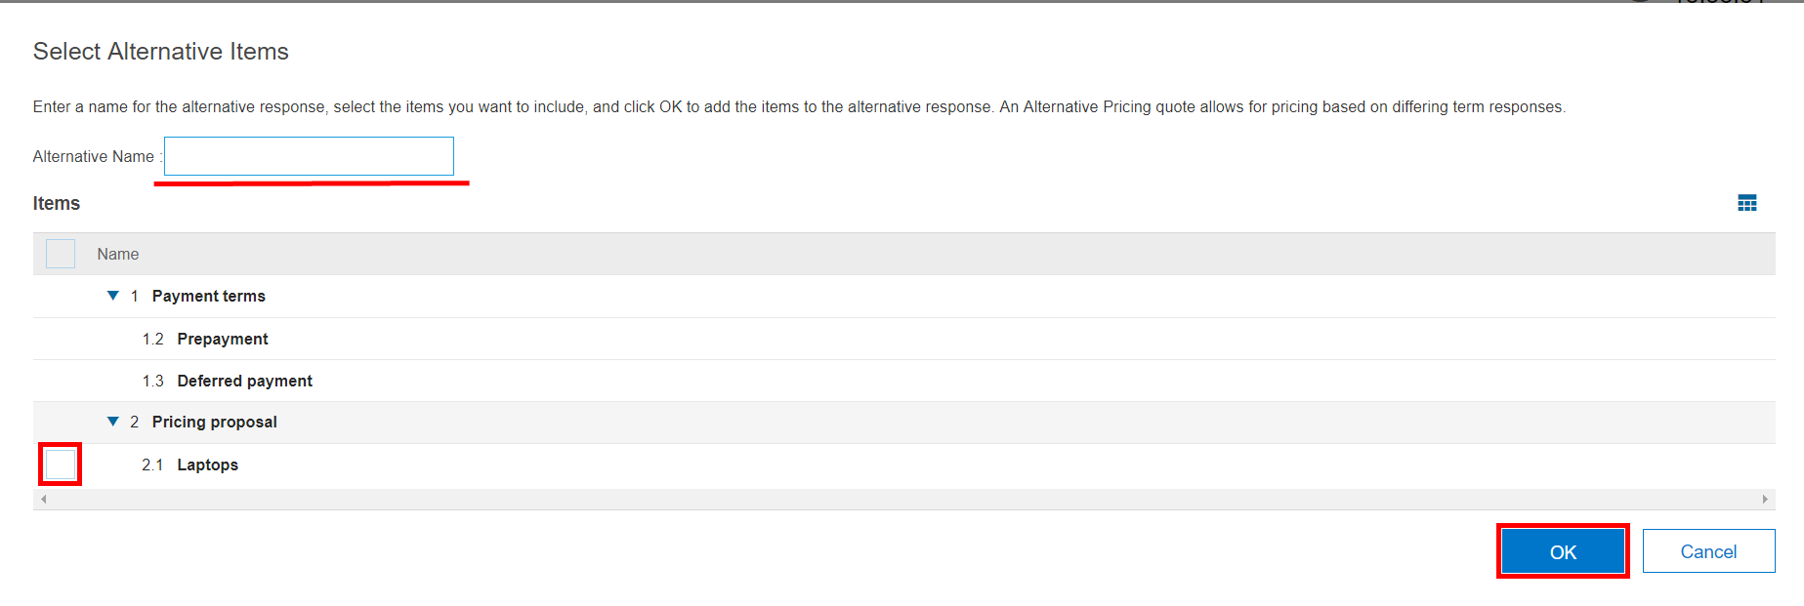
In the alternative response tab complete the necessary information and click “Submit Entire Response” – “OK”.
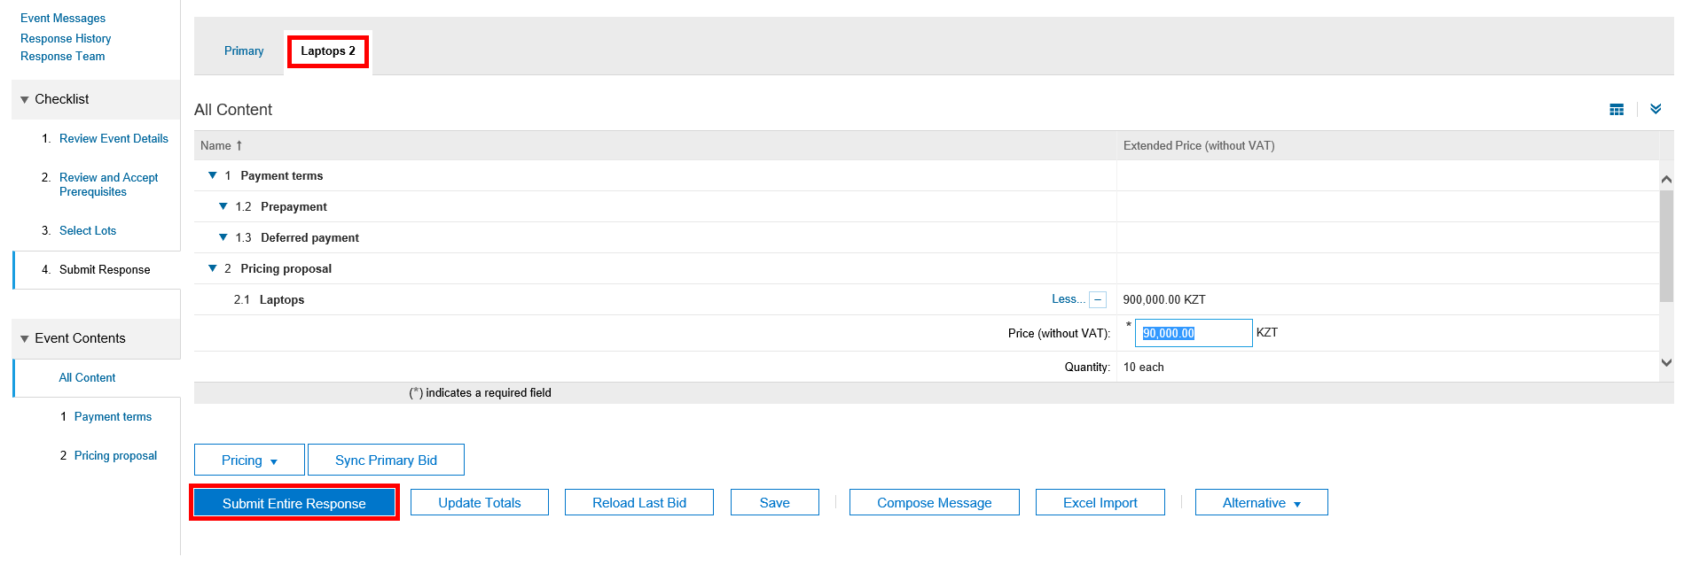

Supplier account management
A supplier account in Ariba Network can be managed with the help of the home dashboard. The dashboard consists of the following tools:
- Solutions navigator;
- Company settings;
- User account navigator;
- Help center.
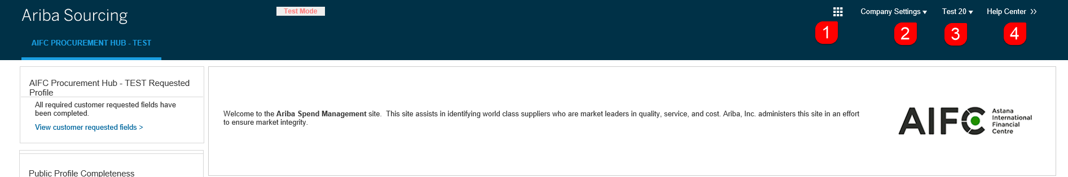

Solutions navigator
Select “Proposals” to open Ariba Sourcing module. Here Astana International Financial Centre publish their sourcing events.
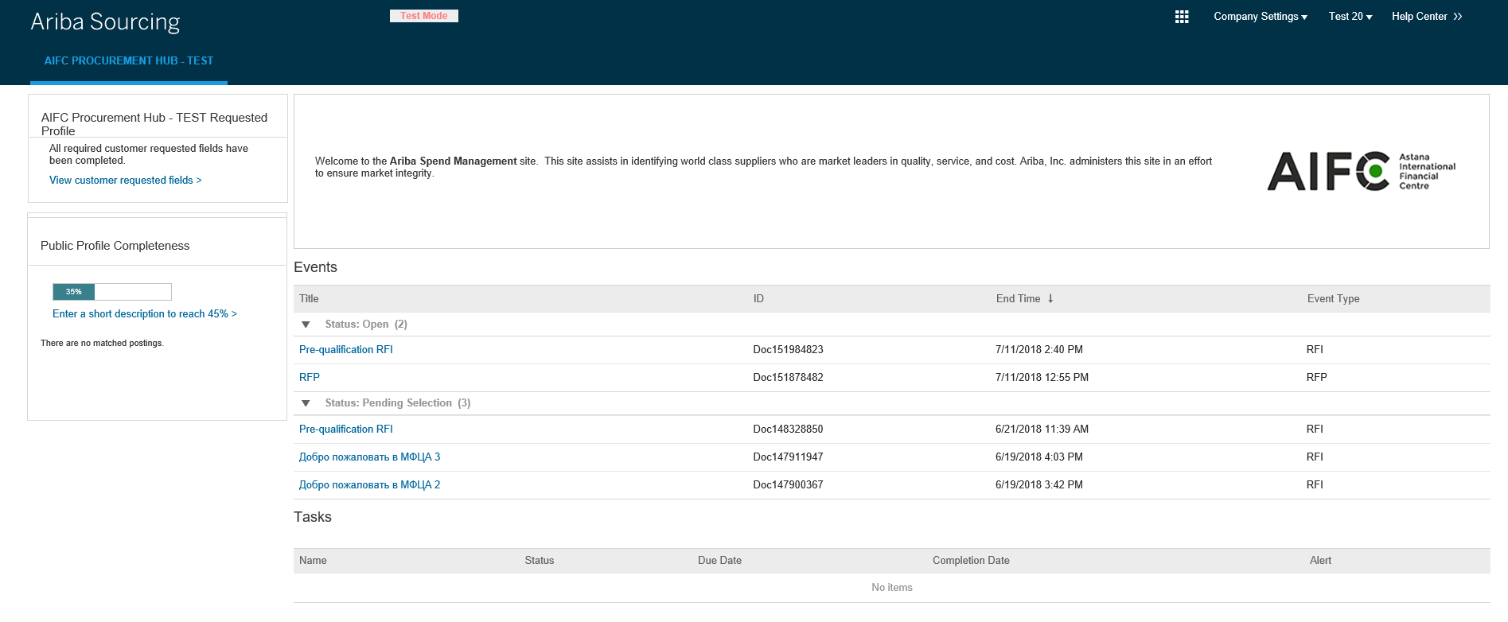

Company Settings
In “Company Settings” section you can configure your account data, application subscriptions, notifications, payment and bank information and customer's transaction rules. Available options depend on your permissions and the Ariba solution that you have chosen.
Open “Company profile” to complete your organization profile.
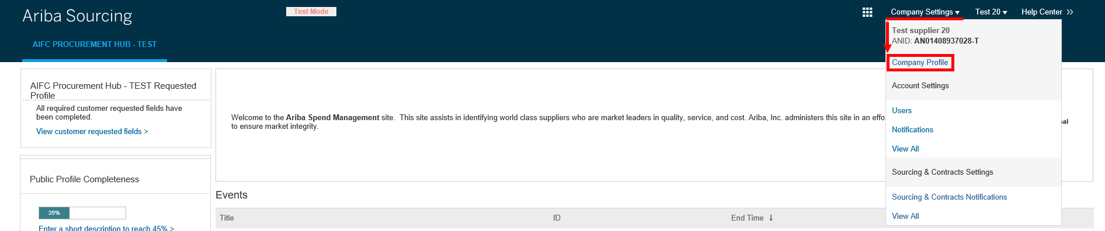
You can check how AIFC see your company profile using “View Public Profile” option. Use “Profile Visibility Settings” option to configure visibility settings of your company profile.
You can complete and edit different information of your company profile in company profile tabs.
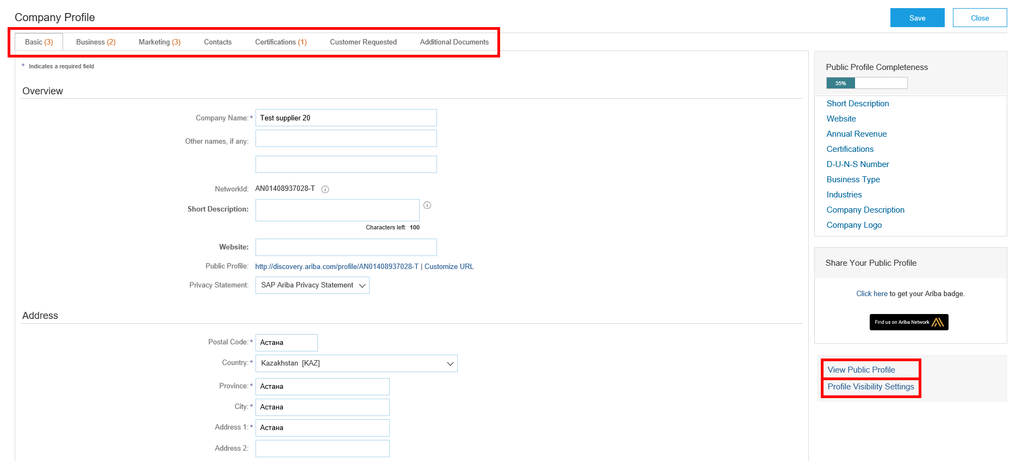

Changing supplier profile questionnaire (SPQ)
- Go to “Company Settings” – “Company Profile” to change the information in the supplier profile questionnaire.
- Go to “Customer Requested” tab and click on the name of AIFC supplier profile questionnaire.
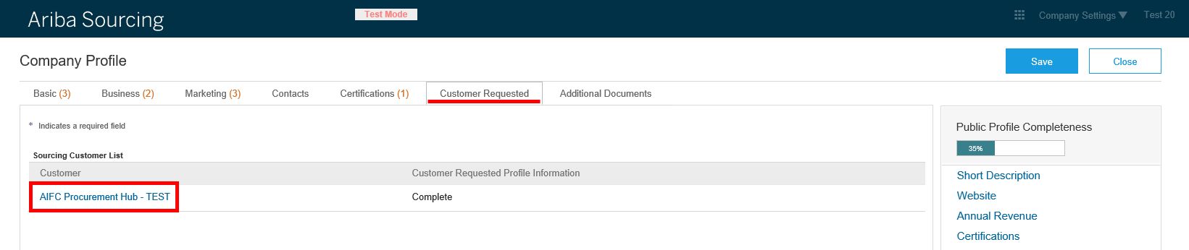
- Make changes, click “Submit”, close the questionnaire using “X”, then click “Save” – “Close”.

Help Center
Help Center displays useful information on the right side of the screen. Here you can access the user documentation, articles, training materials and Ariba support service.

User account navigator
User account navigator allows you to change account settings and password, it also can help you link user IDs and contact you administrator.

Changing your user account information and password
Click your name at the top of the dashboard and click “My Account” to display the User Information page.
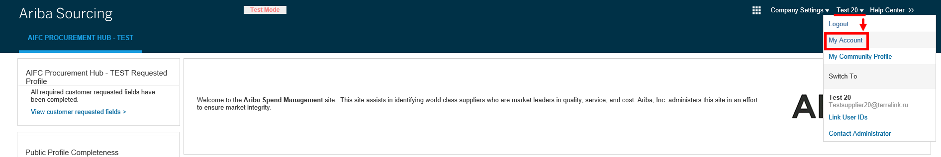
In the Account Information section you can update values as necessary, then click “Save”. Your changes take effect at your next login.
To change your password click “Change Password”, enter your current and new passwords, noting the following constraints and guidelines:
- Passwords are case-sensitive, must be at least eight characters long;
- You can include only alphabetic letters (without accents), numbers, and common symbols.
- For increased security, you should include at least one numeral between the first and last characters and at least one common symbol.
Then click “Save Password” – “Save”.

About Business Roles
Your Business Role determines the default action tiles displayed on the Ariba Network dashboard. New Ariba Network users are asked to select a Business Role during account creation. Existing Ariba Network users who have not yet selected a business role will be prompted to select one the next time they log in. You can select or change your Business Role from the “My Account” page at any time.

Linking user accounts
If you have multiple user accounts, you can link their IDs together.
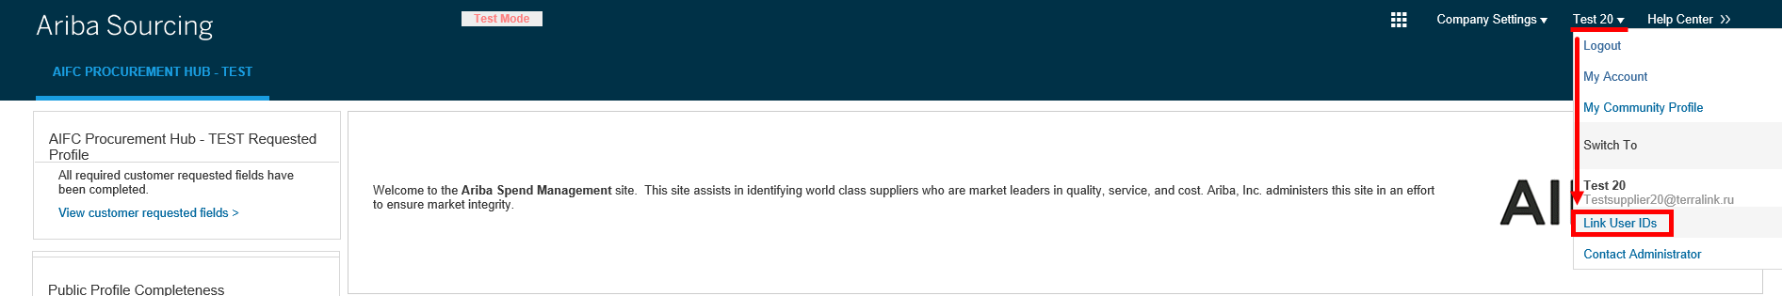
- Click your name at the top of the dashboard;
- Click “Link User IDs” to display the Link Accounts page;
- Enter the username and password of the user account you want to link with and click “OK”. SAP Ariba displays a confirmation message, indicating that your user accounts are now linked.
- Click “Done”.
As a result the user profile menu displays multiple User Account IDs in “Switch To” section.

Contacting your account administrator
If you have questions or problems you can contact your account administrator. To view your account administrator's contact details, click your name at the top of the page and select “Contact Administrator”.
